Performance Tuning:

**Tools of Performance Tuning:**

1. **Code Inspector :**

Done using 2 ways : - 1) Through SE80 or Through SCI

Method 1 ->>> Go to SE80-> go to you package-> go to a program-> right click-> Select Check-> Code Inspector-> it shows the result of the inspection-> list of warnings, erros, information-> u can expand each and study in detail. You will get more information about the errors in syntax check /Generation.

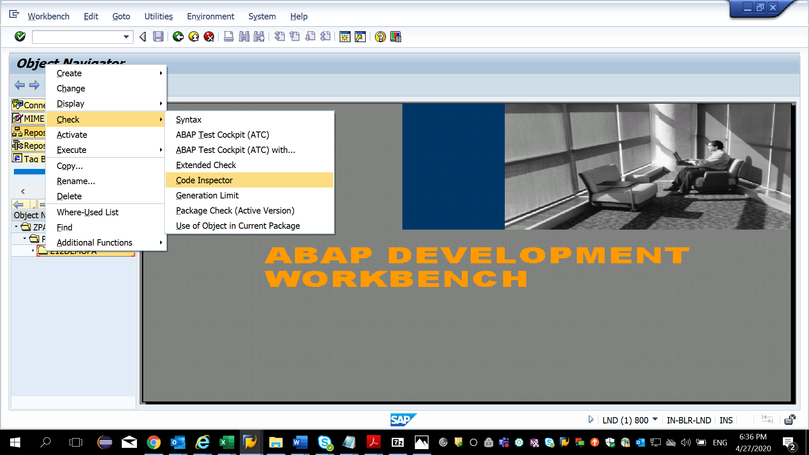

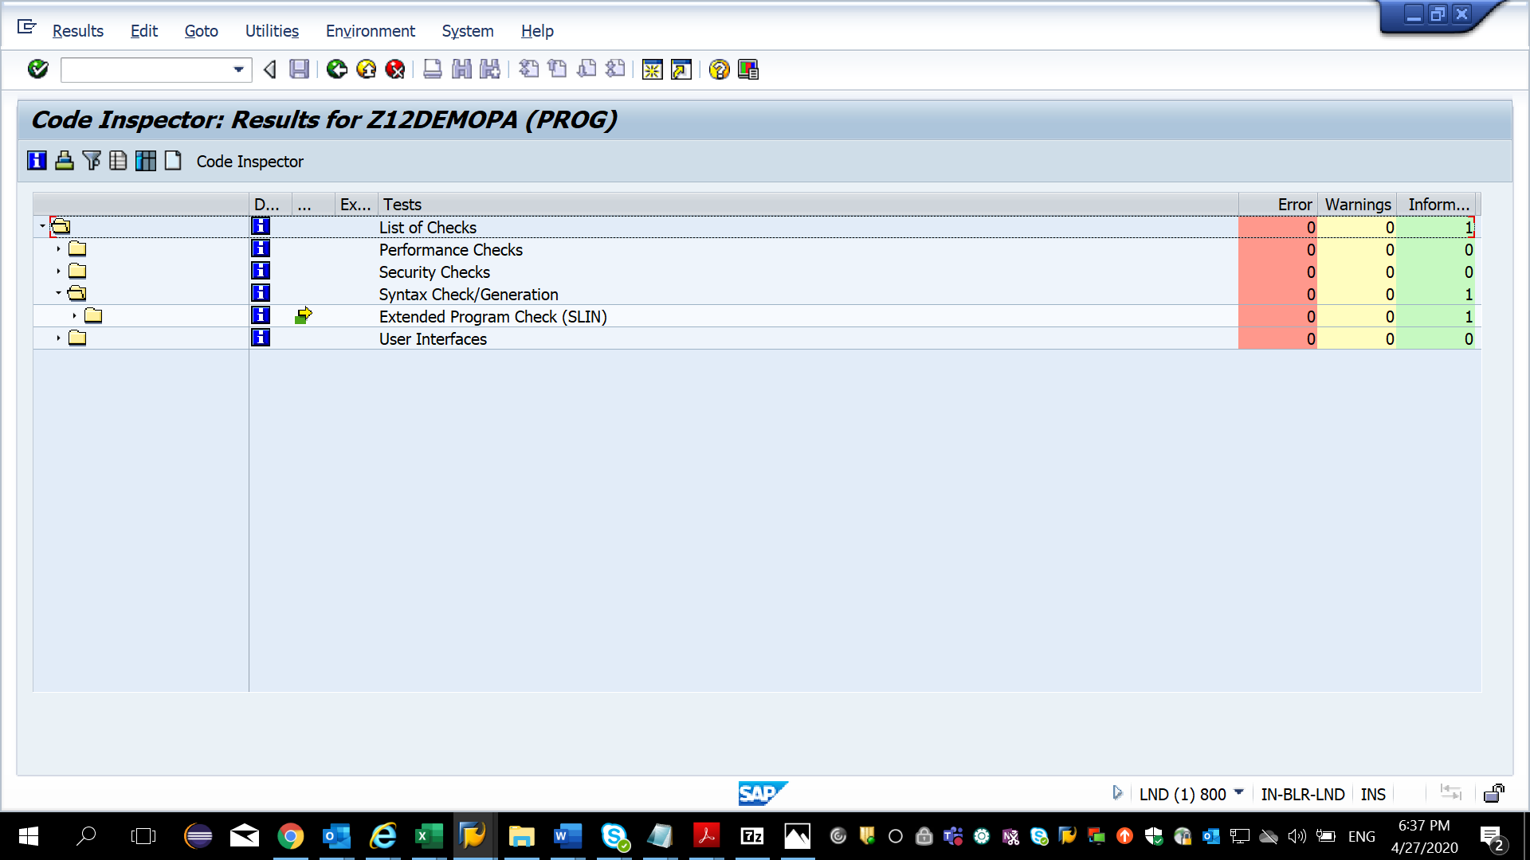

Method 2: GO to TCode SCI-> Create a variant -> this will have all the checks we want to perform on the program

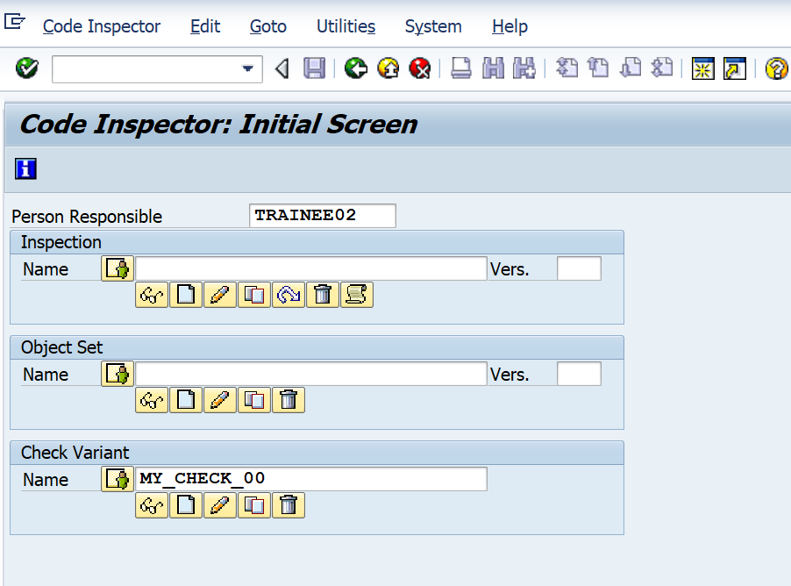

Select the checks u want to perform on the program or object set.

Save it

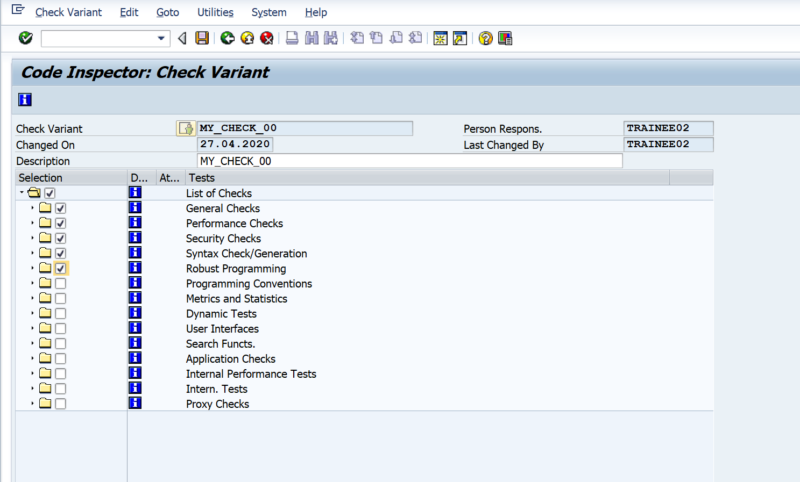

Create the object set.

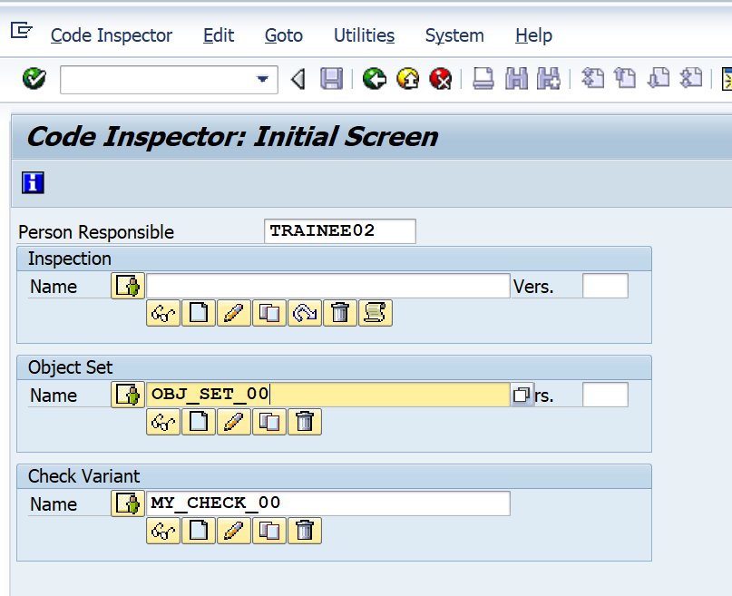

Give the deletion date and then Specify the program name or function module or any object u want to check and save:

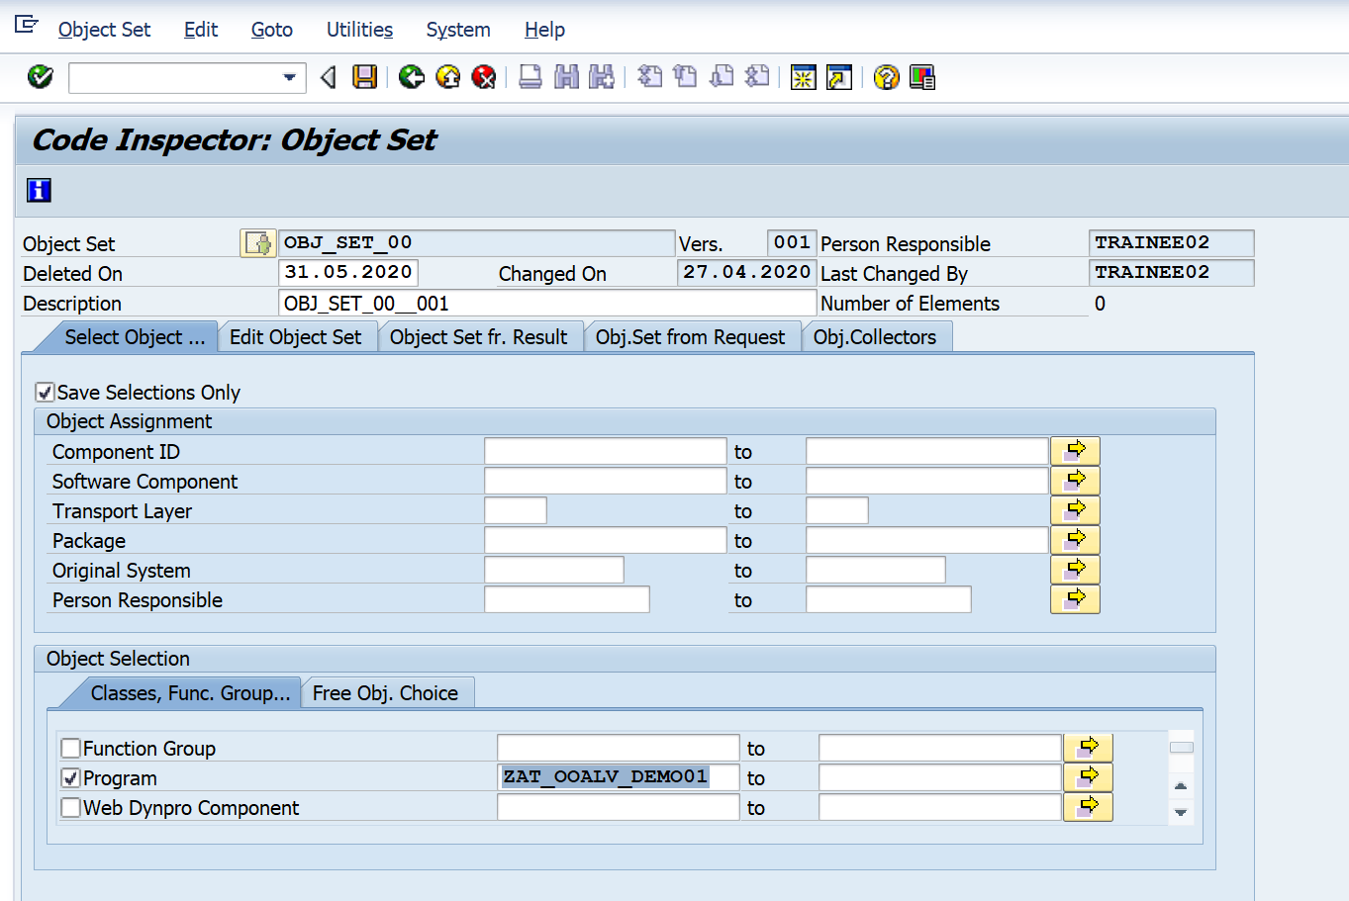

Create the inspection :

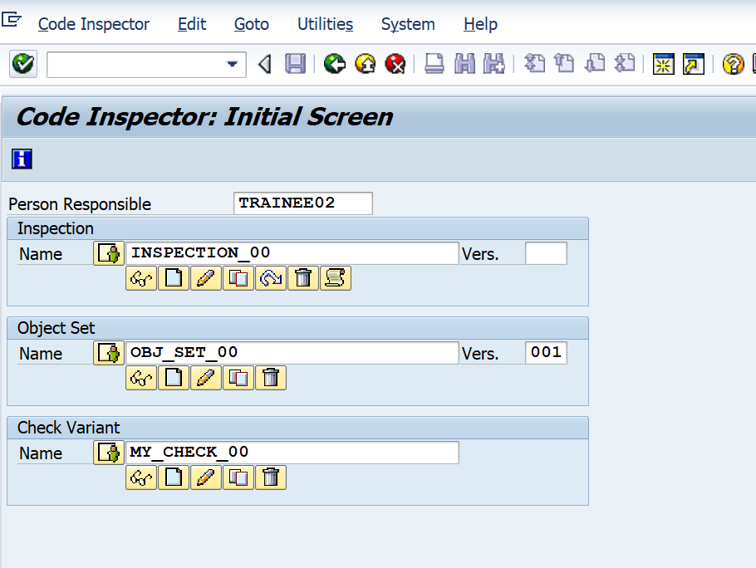

And enter the object set and the variant name created earlier and save.

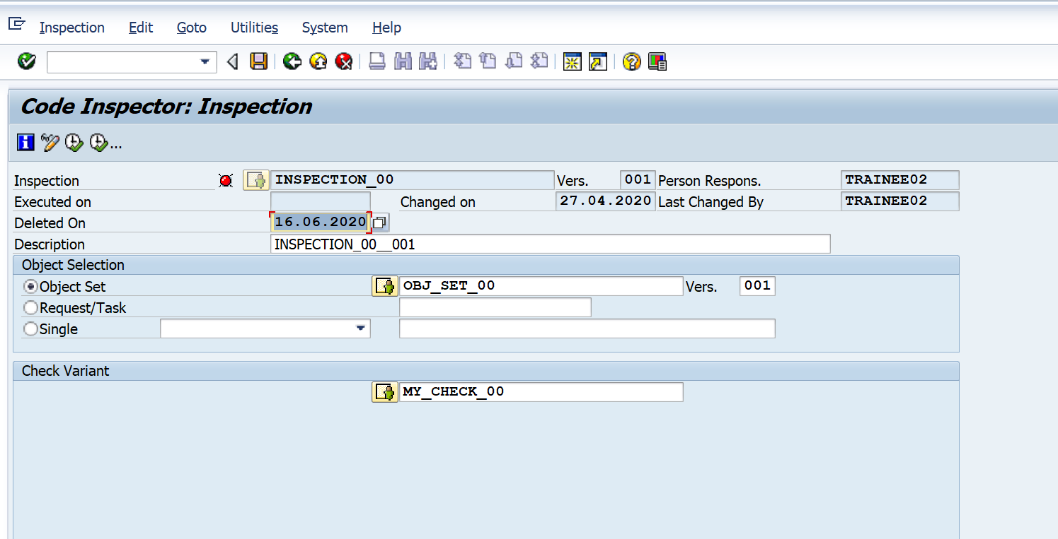

Method 3: Go to SE38 and then go to the progam and then click on Programs-> Check->Code Inspector

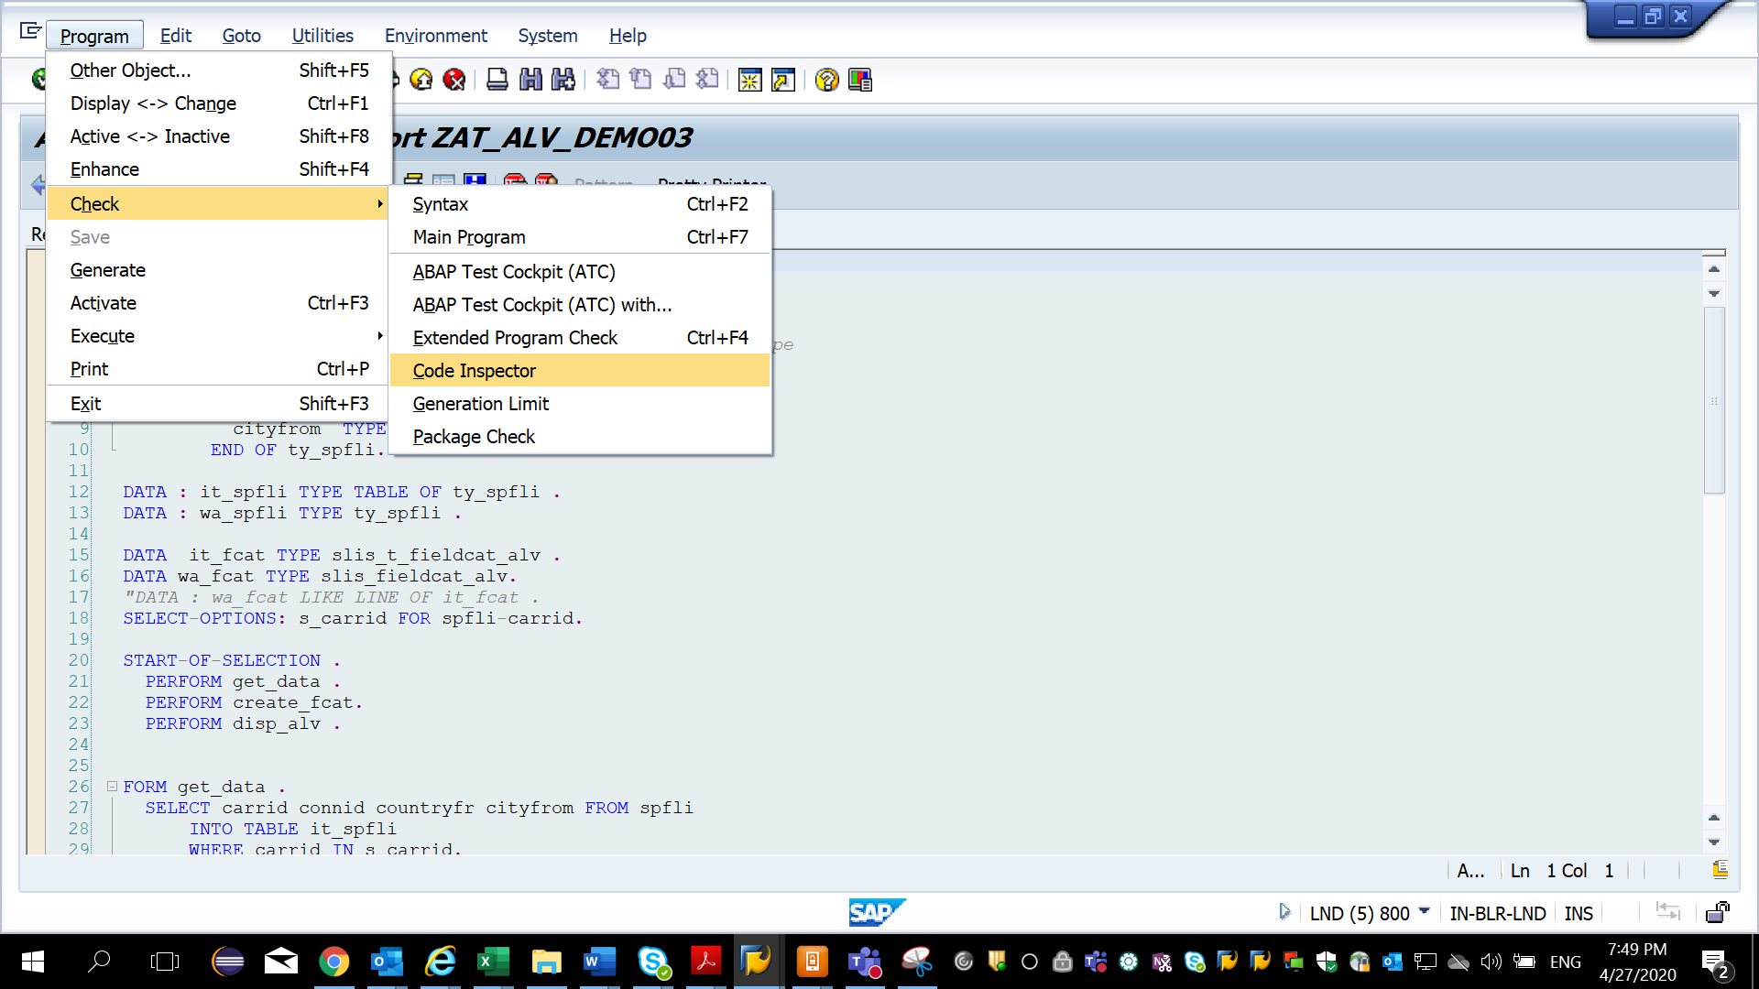

1. Extended Program Check: Go to SE38 . Click on Programs ( use simple ALV demo first)- > select Extended Program Check.

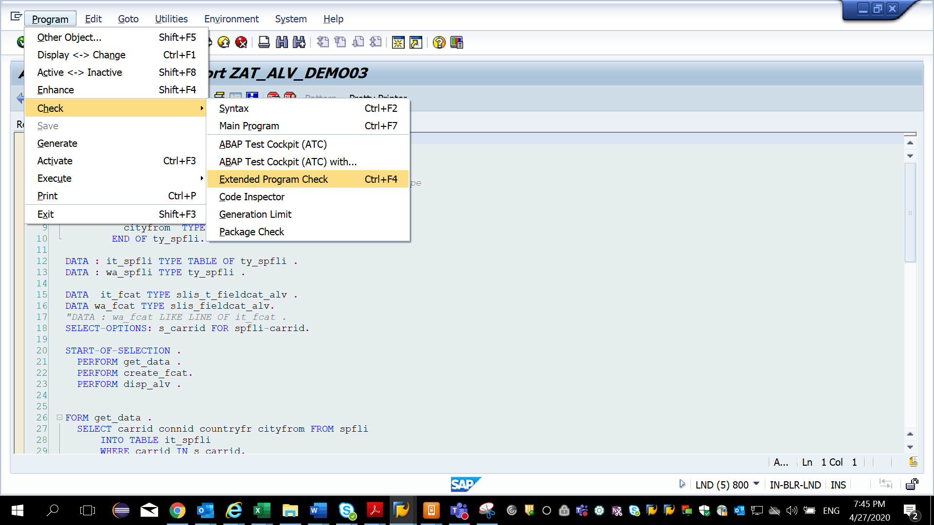

Select the checks and then execute

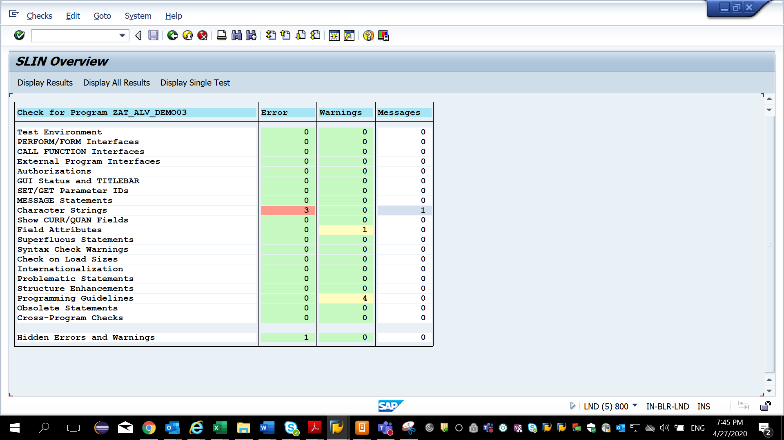

Click on the erros to dive in and understand:

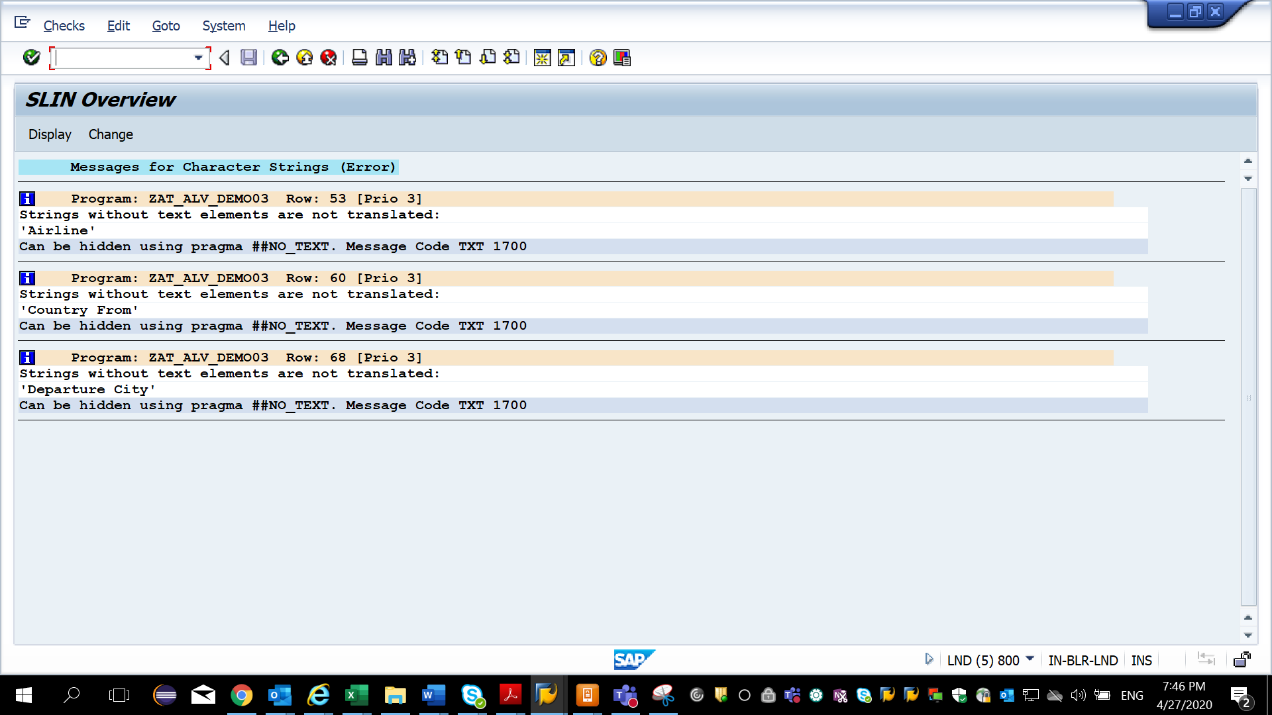

Whatever is given in Pragma section – if it is written then the tool will skip these issues.

1. **Performance Trace : Tcode – ST05 :** Trace allows you to record database access, locking activities etc

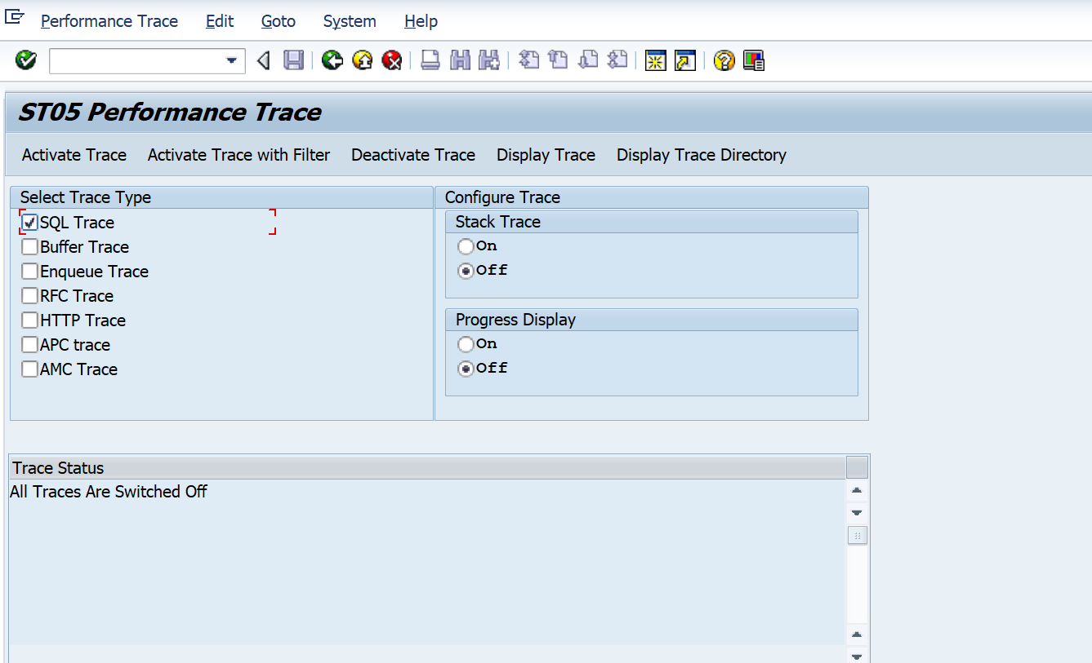

Steps:

1. Go to Tcode ST05
2. Click on Activate Trace
3. Go to any simple SE 38 and run ur program
4. Come back to ST05 and deactivate Trace
5. Display Trace

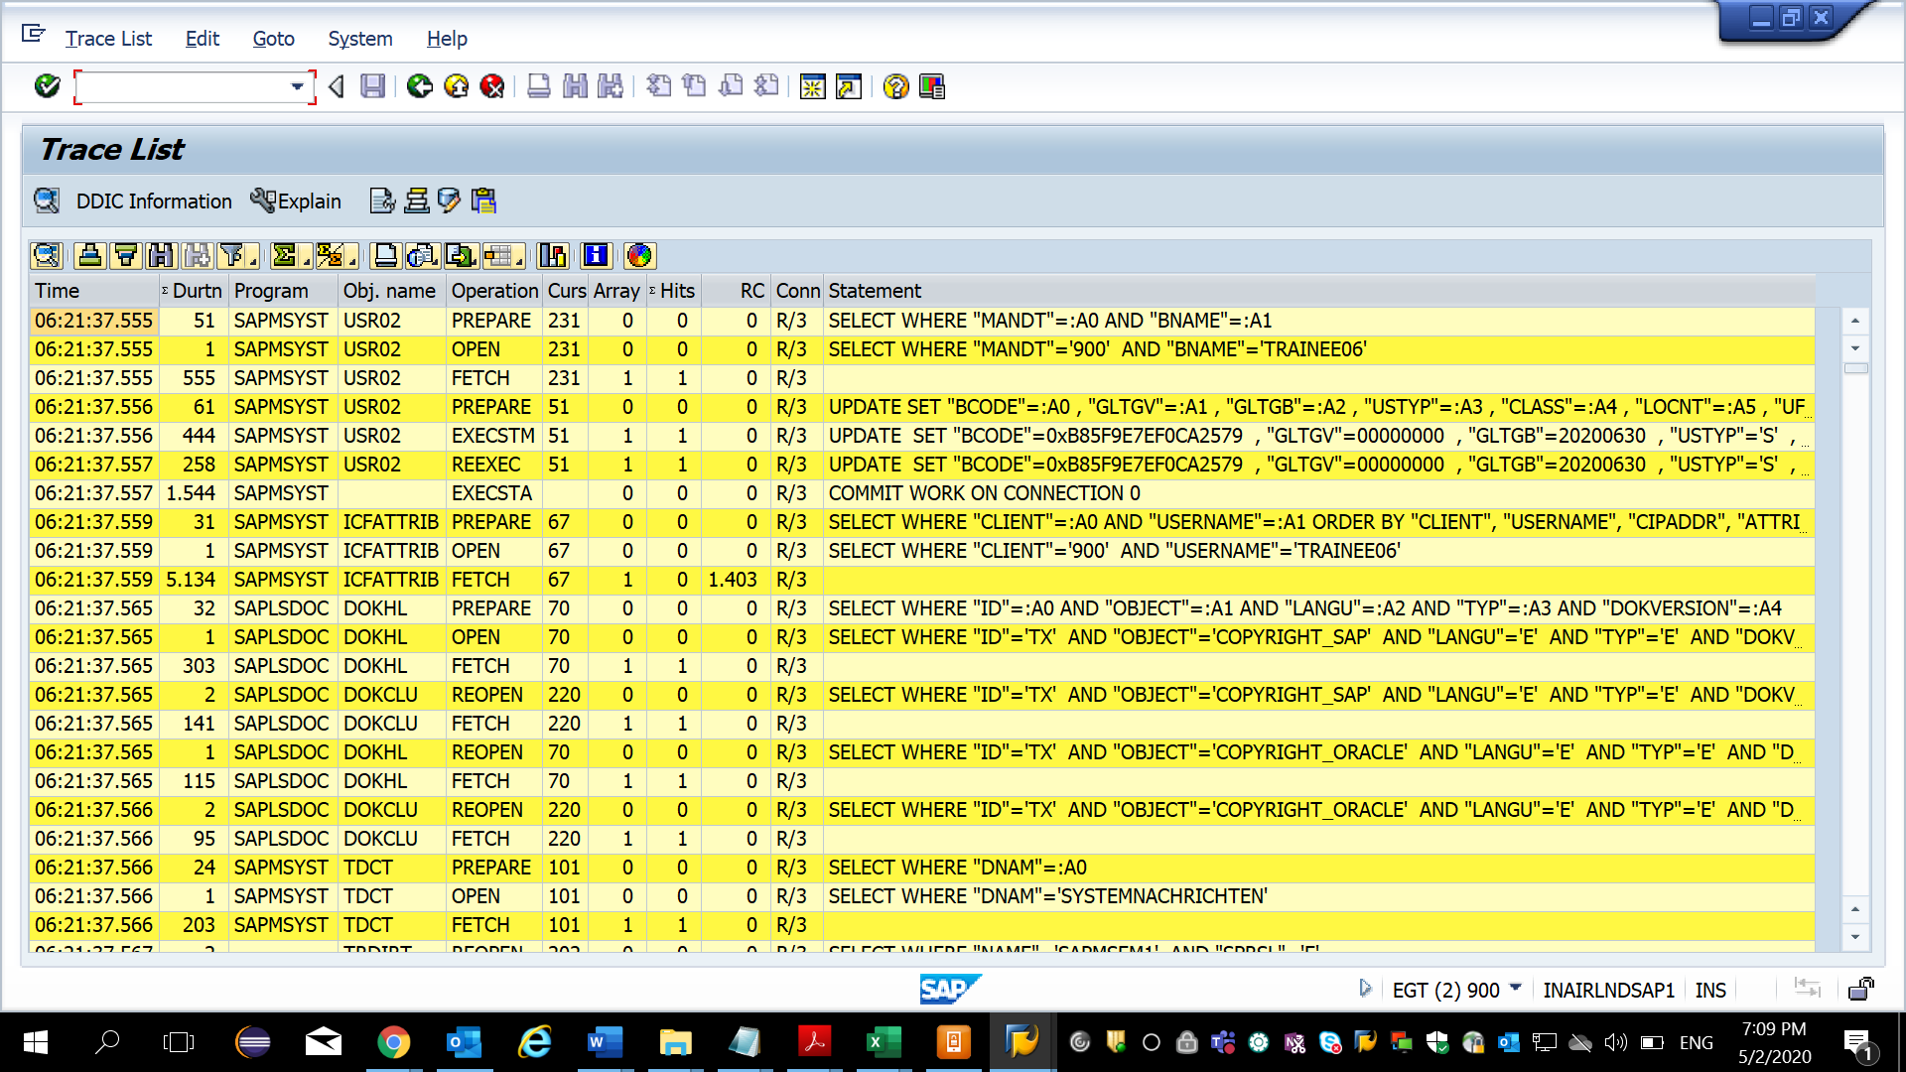

1. SE30 ABAP Run Time Analysis :
2. Go to Tcode SE30 .
3. Give program name and click on execute. It executes the program and then click back. It comes back to SE30.
4. Then click on Evaluate button at the bottom left corner.
5. You can see graphs of how much time it took to execute the program at ABAP level and at DB level.

